ITA0304 MOBILE COMPUTING
CO2 ASSESSMENT TOOL 2
1,2:
https://www.figma.com/design/wGXyCRnWVXGRXbmpqa9LOL/CO2-AT-2?node-id=15-19&t=4CyxLrwXZsJo2s1M-1
3.
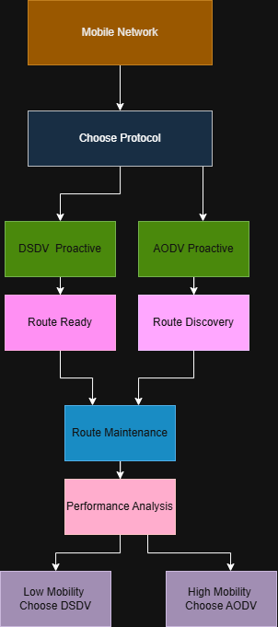

4.
